TASKS

1. Read a CSV file with data in multiple columns and compute mean, median and mode of each of the columns.

import pandas as pd

import matplotlib.pyplot as plt

import numpy as np

df=pd.read_csv('/content/drive/MyDrive/data.csv')

print(df)

print("\nMean of Pulse:")

print(df['Pulse'].mean())

print("\nMedian of Pulse:")

print(df['Pulse'].median())

print("\nMode of Pulse:")

print(df['Pulse'].mode())

OUTPUT

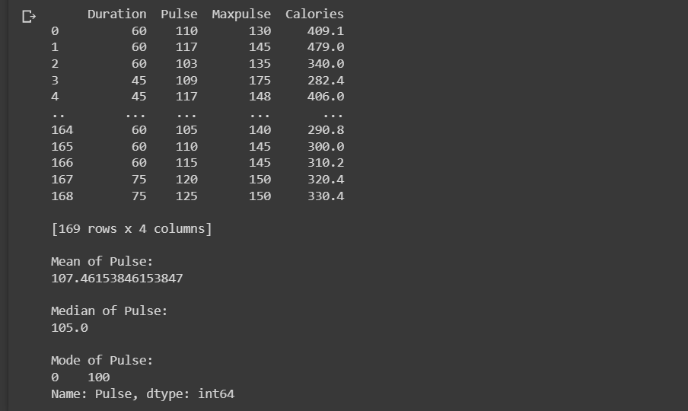

2. Plot each of the columns with different colors (check what kind of graph is suitable).

import pandas as pd

import matplotlib.pyplot as plt

import numpy as np

df=pd.read_csv('/content/drive/MyDrive/data.csv')

Pulse=df['Pulse']

Calories=df['Calories']

plt.figure(figsize=(8,8))

plt.pie(Pulse,labels=Pulse)

plt.title("Pie chart showing")

plt.show()

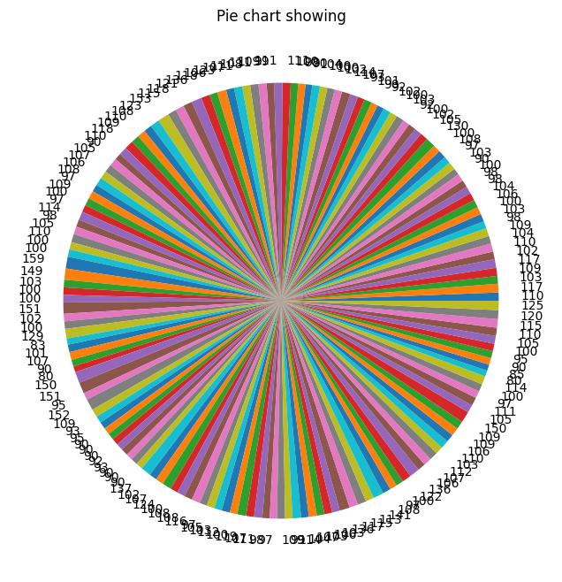

import pandas as pd

import matplotlib.pyplot as plt

import numpy as np

df=pd.read_csv('/content/drive/MyDrive/data.csv')

Pulse=df['Pulse']

Calories=df['Calories']

plt.bar(Pulse,Calories,color=['red','blue','green'])

plt.show()

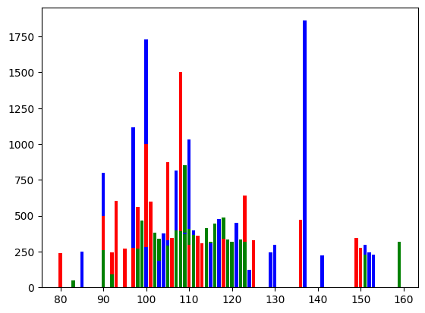

3. Create a game (like lottery/rock, paper, scissors) and write a python code how many times the computer won and the user won in an Excel file. Plot the graph showing the success rate of user and computer with different color.

import random

print("Welcome to Hand cricket")

lis1=[]

n=1

while n<=2:

print("Player",n,":")

sum=0

for i in range(1,7,1):

x=int(input("Enter the number"))

y=random.randint(1,6)

if x==y:

print("out")

print(x)

print(y)

break

else:

sum=sum+x

print(x)

print(y)

print("Total of player",n,"is",sum)

lis1.append(sum)

n=n+1

if lis1[0]>lis1[1]:

print("Player 1 Won by",lis1[0]-lis1[1])

else:

print("Player 2 won by",lis1[1]-lis1[0])

OUTPUT

**Welcome to Hand cricket**

**Player 1 :**

**Enter the number3 3 5**

**Enter the number2 2 3**

**Enter the number1 1 5**

**Enter the number4 4 2**

**Enter the number2 2 6**

**Enter the number1 1 5**

**Total of player 1 is 13**

**Player 2 :**

**Enter the number4 4 1**

**Enter the number2 2 4**

**Enter the number1 1 3**

**Enter the number3 3 1**

**Enter the number1 1 3**

**Enter the number3 3 6**

**Total of player 2 is 14**

**Player 2 won by 1**